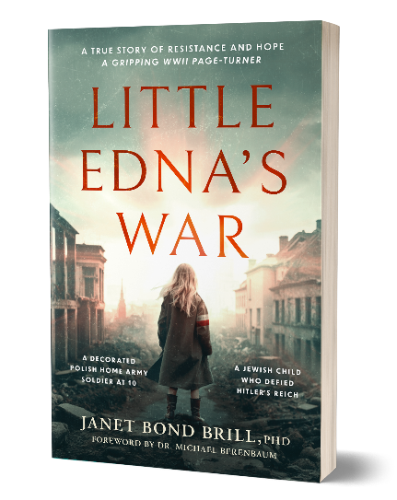

LITTLE EDNA'S WAR
A True Story of Resistance and Hope

"Pope Pius XII decorated a Jewish child... and had no idea."

Smuggler at 7. Armed fighter at 9. Decorated soldier at 10.
Jewish girl who made history — and survived to tell it.

WHY THIS BOOK. WHY NOW.
Antisemitic incidents are at record highs. Holocaust denialism is rising. Survivors are dying. Little Edna's War is not just a memoir — it's testimony. Publishing on International Holocaust Remembrance Day (January 27, 2026), this book arrives when the world needs it most. "Indifference is complicity." — Edna's message to her grandchildren

THE STORY
Born at Mila 18 in the heart of Jewish Warsaw, Edna Stefania Brill was not quite five years old when Nazi bombs fell on her friend's birthday party — the last moment of her childhood. What followed defies belief: she became a child smuggler in the Warsaw Ghetto, escaped to the Aryan side under a false Catholic identity, and joined the Polish Home Army (Armia Krajowa) as a courier and fighter. She was the youngest decorated soldier in Polish resistance history. So convincing was her Catholic persona that Pope Pius XII personally blessed her as an exemplary Catholic war hero — never knowing she was Jewish.

HEADLINES THAT SELL
- "Pope Pius XII Blessed a Jewish Child — And Never Knew" — Edna's papal audience while hiding her identity
- "Performing for the Gestapo to Stay Alive" — How two Jewish girls survived as street performers on the Aryan side
- "First Female POWs in History" — Edna was one of the Oberlangen girls, first female soldiers granted POW status
- "I Don't Know Any Hebrews" — After the war, Edna denied knowing her own brother when he came to claim her
- "The Birthday Party Was the Last Moment of My Childhood" — Edna was not quite 5 when the bombs fell, September 1, 1939

CREDIBILITY & COMPARISONS
Foreword by Dr. Michael Berenbaum — Former Project Director, U.S. Holocaust Memorial Museum
For readers of: The Tattooist of Auschwitz, The Choice, Mila 18, Rena's Promise
Author platform: 4 bestselling health books (Random House, Wiley), 200,000+ copies sold


BOOK DETAILS
Title: | Little Edna's War
Author: | Janet Bond Brill, PhD
Release: | January 27, 2026 (International Holocaust Remembrance Day)
Publisher: | Amsterdam Publishers (Holocaust Survivor True Stories series)
ISBN: | 978-9493418639
Pages: | 364

MEDIA CONTACT
Jeremy Broekman jeremy@broekmancomm.com
www.littleednaswar.com | www.janetbondbrill.com
REQUEST: Interview, excerpt, or review copy Contact Jeremy Broekman to schedule.

